Experiment: Iris Flower Classification using Naive Bayes
Aim
To implement Iris Flower Classification using the Naive Bayes classifier in Python and classify iris flowers into different species.
Procedure
- Import the required Python libraries.
- Load the built-in Iris dataset.
- Separate the dataset into input features and target labels.
- Split the dataset into training and testing sets.
- Create a Gaussian Naive Bayes classifier.
- Train the model using the training data.
- Predict the species of the test data.
- Calculate the accuracy of the classifier.
- Display the confusion matrix.
- Predict the class of a new iris flower.
Python Program
Python
Run
from sklearn.datasets import load_iris
from sklearn.model_selection import train_test_split
from sklearn.naive_bayes import GaussianNB
from sklearn.metrics import accuracy_score, confusion_matrix

# Load Iris dataset
iris = load_iris()

# Input features
X = iris.data

# Target values
y = iris.target

print("Iris Flower Classes:")
print(iris.target_names)

# Split dataset into training and testing data
X_train, X_test, y_train, y_test = train_test_split(
X, y,
test_size=0.3,
random_state=42
)

# Create Naive Bayes classifier
model = GaussianNB()

# Train the model
model.fit(X_train, y_train)

# Predict test data
y_pred = model.predict(X_test)

# Display actual values
print("\nActual Values:")
print(y_test)

# Display predicted values
print("\nPredicted Values:")
print(y_pred)

# Calculate accuracy
accuracy = accuracy_score(y_test, y_pred)

print("\nAccuracy:")
print(accuracy)

print("\nAccuracy Percentage:")
print(accuracy * 100, "%")

# Confusion Matrix
cm = confusion_matrix(y_test, y_pred)

print("\nConfusion Matrix:")
print(cm)

# Predict a new flower
# [Sepal Length, Sepal Width, Petal Length, Petal Width]
new_flower = [[5.1, 3.5, 1.4, 0.2]]

prediction = model.predict(new_flower)

print("\nNew Flower:")
print(new_flower)

print("\nPredicted Flower:")
print(iris.target_names[prediction[0]])
Sample Output. 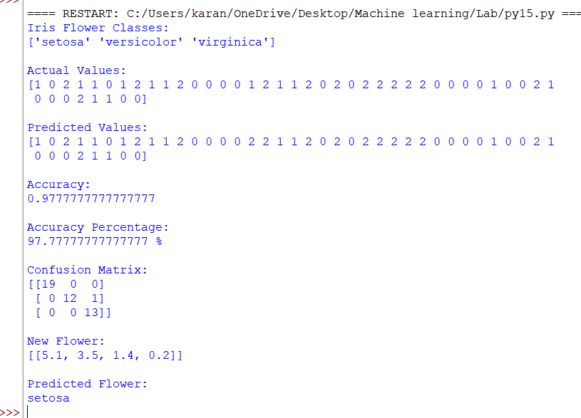
Result
The Iris Flower Classification was successfully implemented using the Gaussian Naive Bayes classifier. The model classified the flowers into three classes: Setosa, Versicolor, and Virginica, and successfully predicted the class of a new iris flower.

